The Indomitable Stickman

SUPPLIES LIST

ESSENTIAL

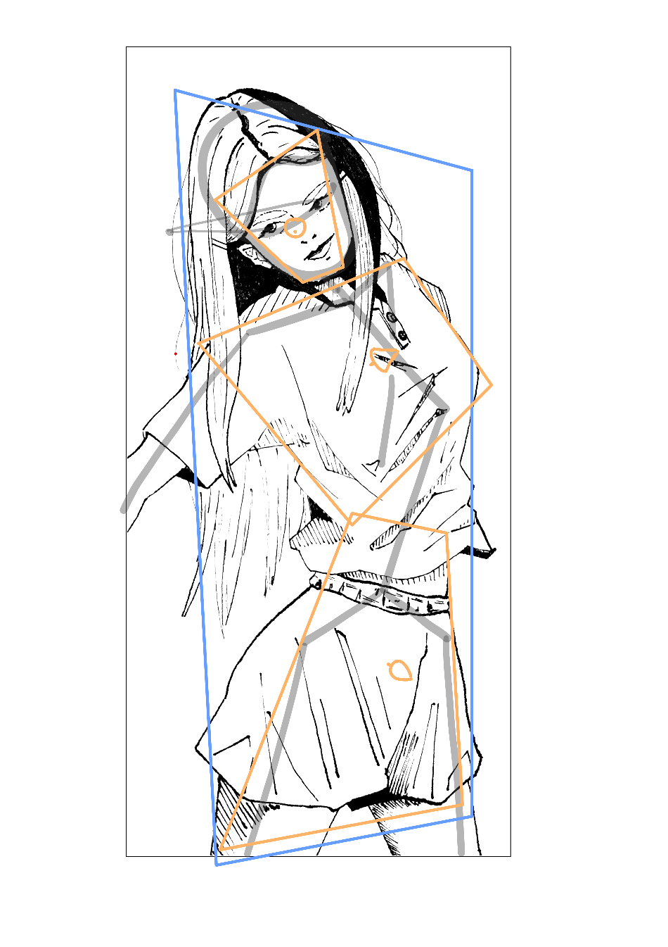**MARK MAKING**

Any Graphite Pencil

* HB, 2B, or 4B will work

At least 2 Coloured Pencils

* Orange and Blue (essential)

Any Pencil Eraser

* Recommend Kneadable Eraser

Straight Edge

* Ruler

Curved edge

* Protractor, Compass, any curved edge (mug or bowl can work)

**PAPER**

A3 – A4 journal

* Approx 110 GSM

OPTIONAL (PERSONAL CHOICE)

Black Felt Tip Pen 0.2mm thickness

Movable figure / wooden dummy / T13 figure